EASTERN INTERNATIONAL UNIVERSITY **Practice Assignment – Quarter 2, 2024-2025**

**SCHOOL OF COMPUTING Course Name:** Database

**AND INFORMATION TECHNOLOGY** **Course Code:** CSE 301

🙙🕮🙛 **Student’s Full Name:**

**Practice Assignment 5**

**Student ID:**

***Instruction*:**

*\* Students are allowed to write their answers (like SQL queries, Screen shot of outputs, etc.) in word file (Answer sheet) provided by instructor. After finishing the assignment, students must convert the word file (Answer sheet) into a PDF file. Finally, students upload the file in Moodle.*

1. **Using the database ‘SaleManagement’ with following schema below:**

Clients(**Client_Number**, Client_Name, Address, City, Pincode, Province, Amount_Paid, Amount_Due)

Product(**Product_Number**, Product_Name, Quantity_On_Hand, Quantity_Sell, Sell_Price, Cost_Price)

Salesman (**Salesman_Number**, Salesman _Name, Address, City, Pincode, Province, Salary, Sales_Target, Target_Achieve, Phone)

Salesorder(**Order_Number**, Order_Date, **Client_Number**, **Salesman_Number**, Delivery_Status, Delivery_Date, Order_Status)

Salesorderdetails(**Order_Number, Product_Number**, Order_Quantity)

1. **Insert more values data below:**

**Salesman**

('S007','Quang','Chanh My','Da Lat',700032,'Lam Dong',25000,90,95,'0900853487')

('S008','Hoa','Hoa Phu','Thu Dau Mot',700051,'Binh Duong',13500,50,75,'0998213659')

**Salesorder**

('O20015','2022-05-12','C108','S007','On Way', '2022-05-15','Successful')

('O20016','2022-05-16','C109','S008','Ready to Ship',null,'In Process')

**Salesorderdetails**

('O20015','P1008',15),

('O20015','P1007',10),

('O20016','P1007',20);

('O20016','P1003',5);

1. **Using Joining table to combine rows from more than one table.**

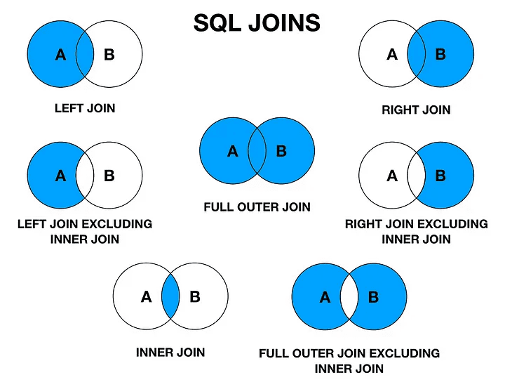

**Read more at: <https://tinyurl.com/SQL-AllJoinTypes>**

|  |
| --- |
| *Supported Types of Joins in MySQL*  *INNER JOIN: Returns records that have matching values in both tables*  *LEFT JOIN: Returns all records from the left table, and the matched records from the right table*  *RIGHT JOIN: Returns all records from the right table, and the matched records from the left table*  *CROSS JOIN: Returns all records from both tables* |

* 1. Display the clients (name) who lives in same city.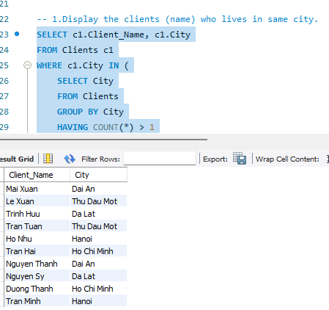
  2. Display city, the client names and salesman names who are lives in “Thu Dau Mot” city.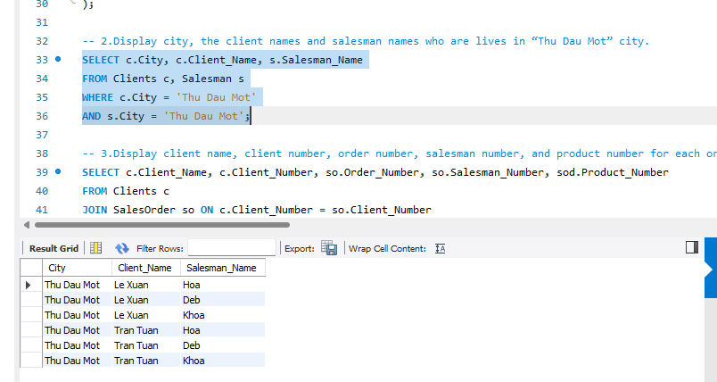
  3. Display client name, client number, order number, salesman number, and product number for each order.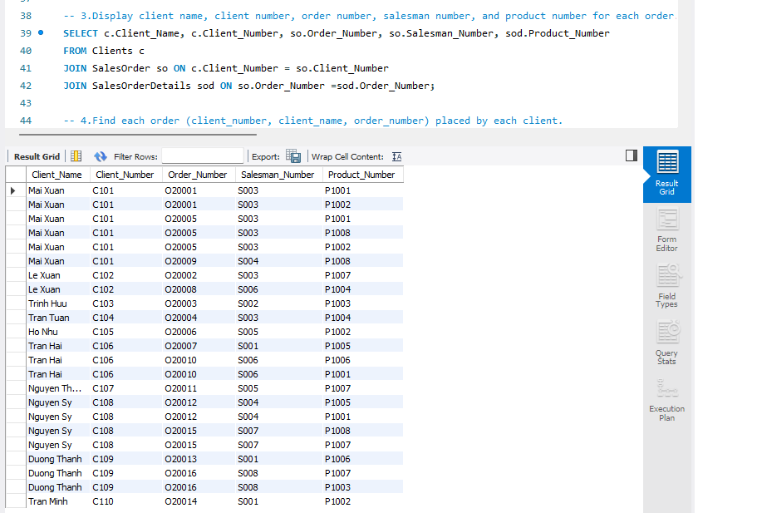
  4. Find each order (client_number, client_name, order_number) placed by each client. 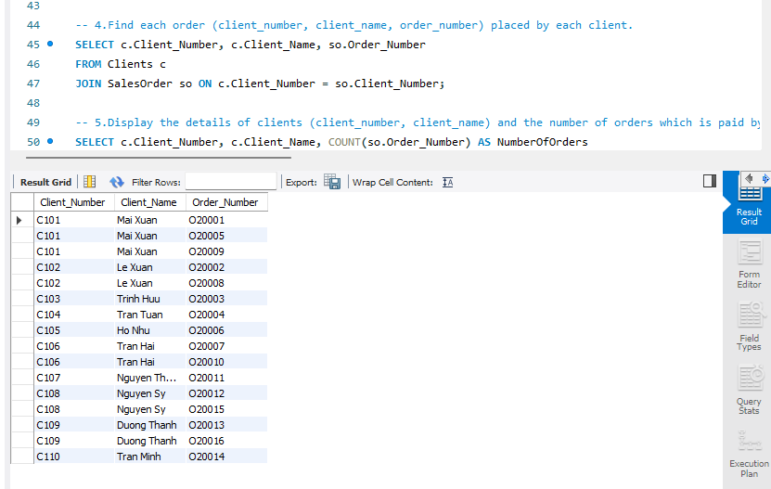
  5. Display the details of clients (client_number, client_name) and the number of orders which is paid by them.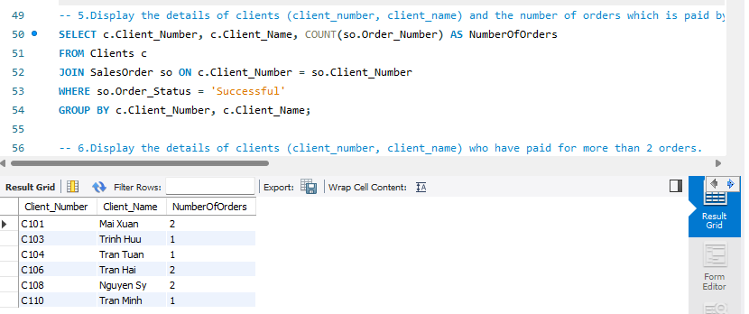
  6. Display the details of clients (client_number, client_name) who have paid for more than 2 orders. 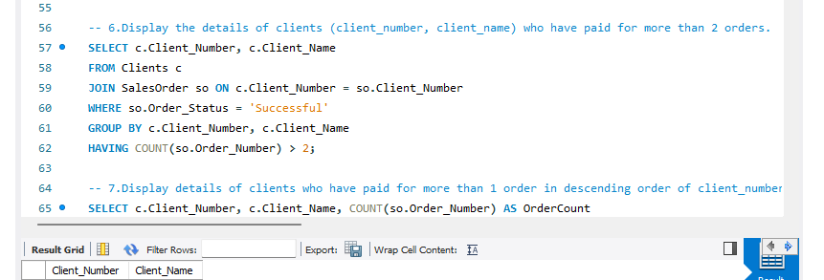
  7. Display details of clients who have paid for more than 1 order in descending order of client_number.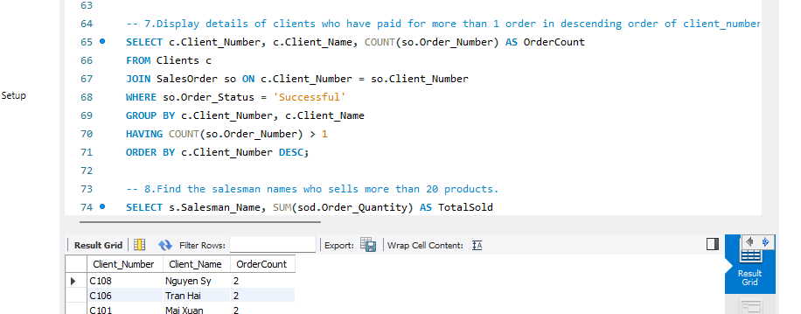
  8. Find the salesman names who sells more than 20 products.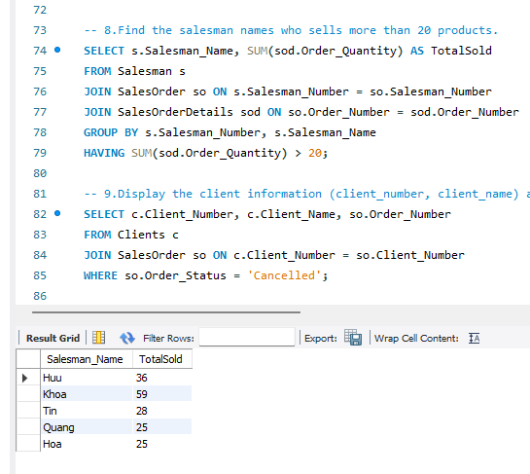
  9. Display the client information (client_number, client_name) and order number of those clients who have order status is cancelled.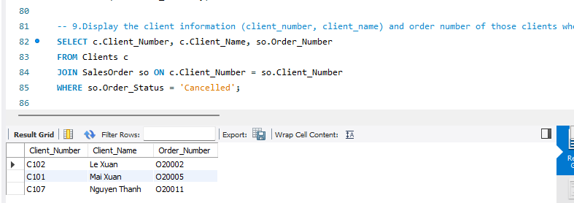
  10. Display client name, client number of clients C101 and count the number of orders which were received “successful”.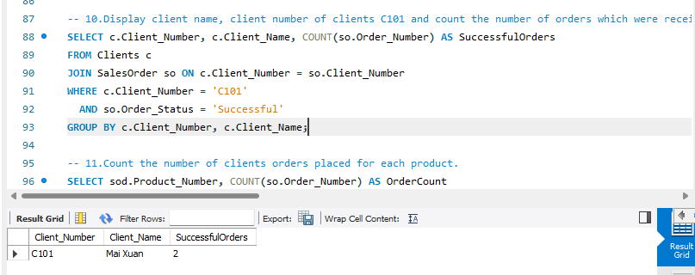
  11. Count the number of clients orders placed for each product.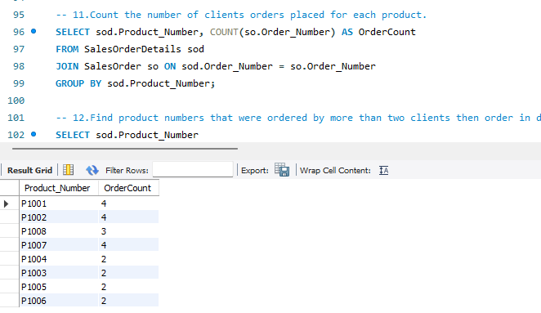
  12. Find product numbers that were ordered by more than two clients then order in descending by product number.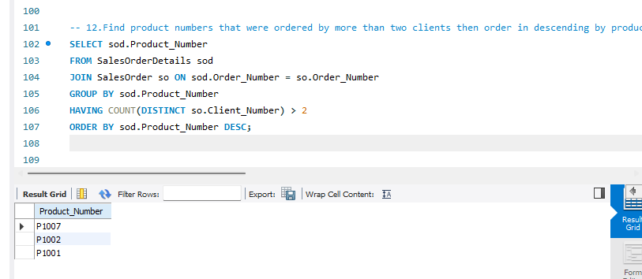

1. **Using nested query with operator (IN, EXISTS, ANY and ALL)**
   1. Find the salesman’s names who is getting the second highest salary.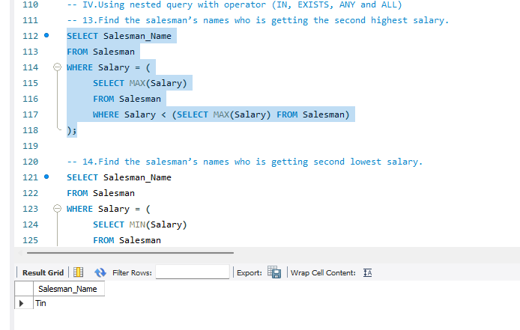
   2. Find the salesman’s names who is getting second lowest salary.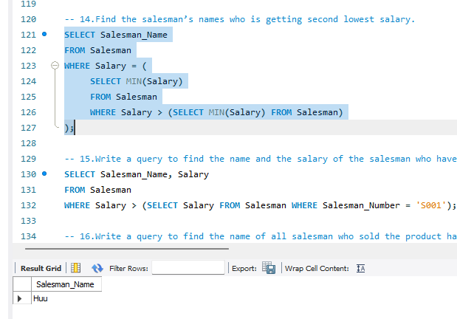
   3. Write a query to find the name and the salary of the salesman who have a higher salary than the salesman whose salesman number is S001.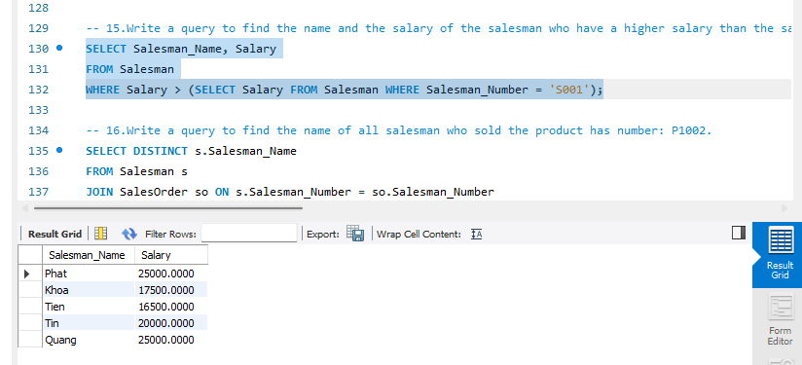
   4. Write a query to find the name of all salesman who sold the product has number: P1002.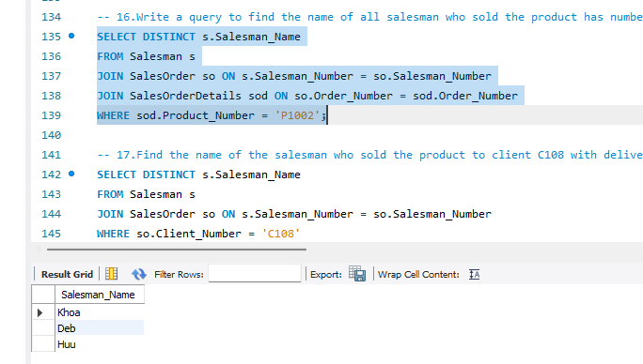
   5. Find the name of the salesman who sold the product to client C108 with delivery status is “delivered”.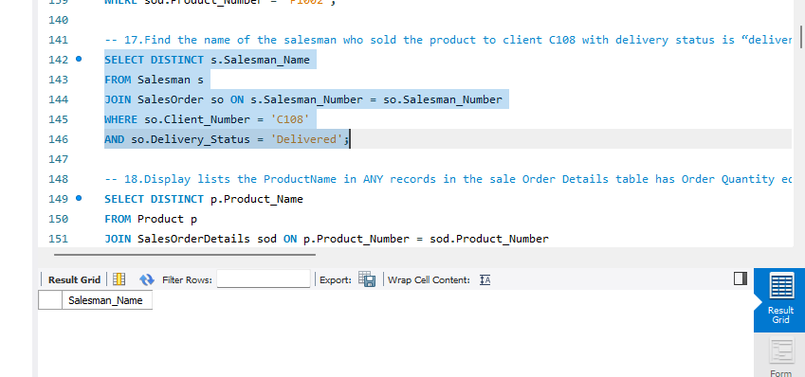
   6. Display lists the ProductName in ANY records in the sale Order Details table has Order Quantity equal to 5.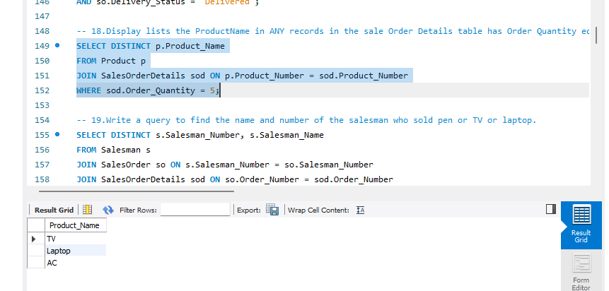
   7. Write a query to find the name and number of the salesman who sold pen or TV or laptop.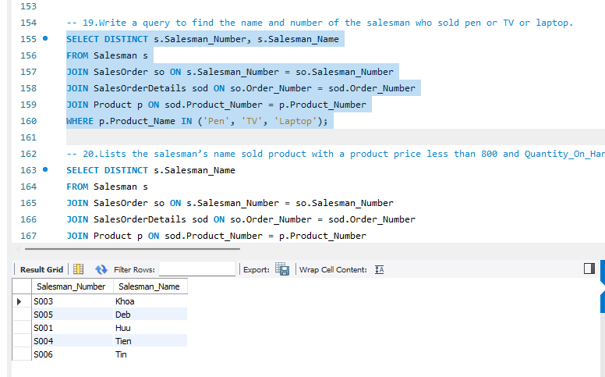
   8. Lists the salesman’s name sold product with a product price less than 800 and Quantity_On_Hand more than 50.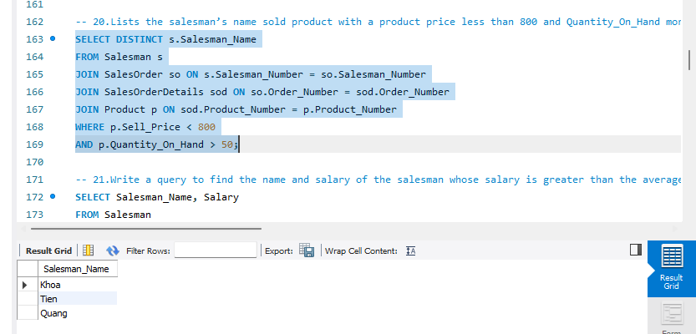
   9. Write a query to find the name and salary of the salesman whose salary is greater than the average salary.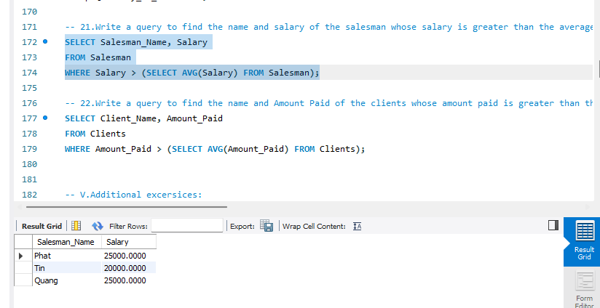
   10. Write a query to find the name and Amount Paid of the clients whose amount paid is greater than the average amount paid.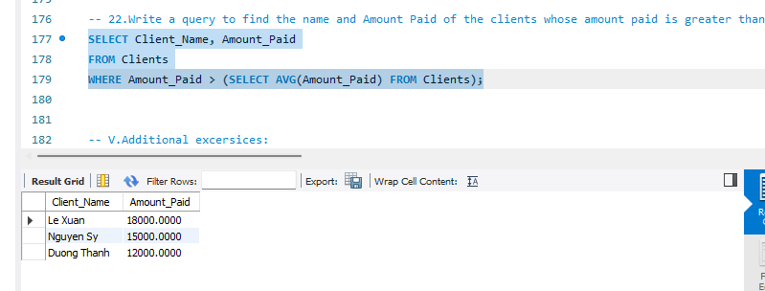
2. **Additional excersices:**
   1. Find the product price that was sold to Le Xuan.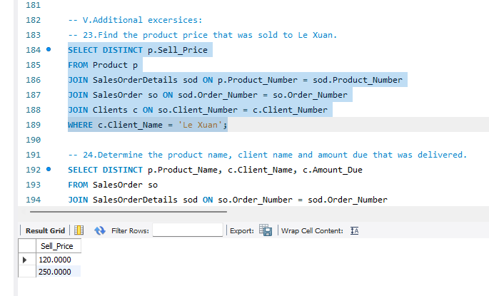
   2. Determine the product name, client name and amount due that was delivered.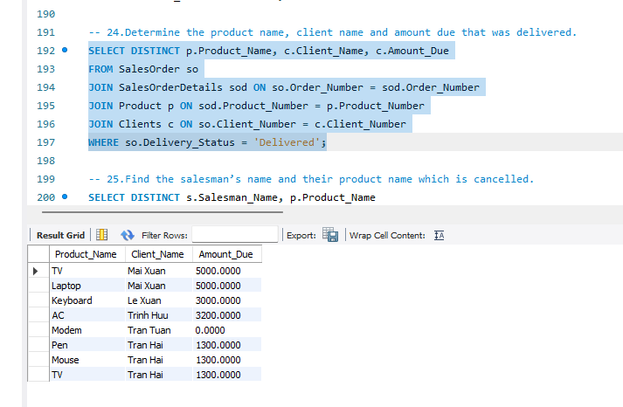
   3. Find the salesman’s name and their product name which is cancelled.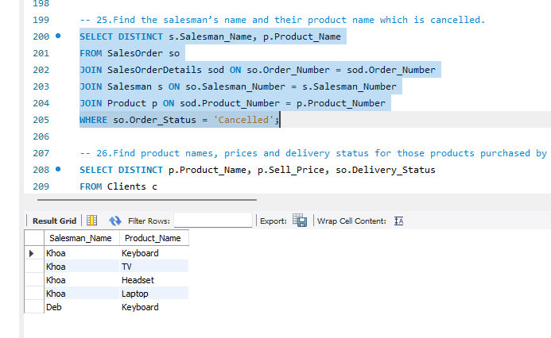
   4. Find product names, prices and delivery status for those products purchased by Nguyen Thanh.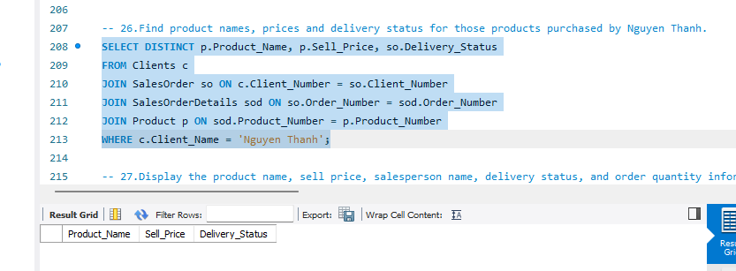
   5. Display the product name, sell price, salesperson name, delivery status, and order quantity information for each customer.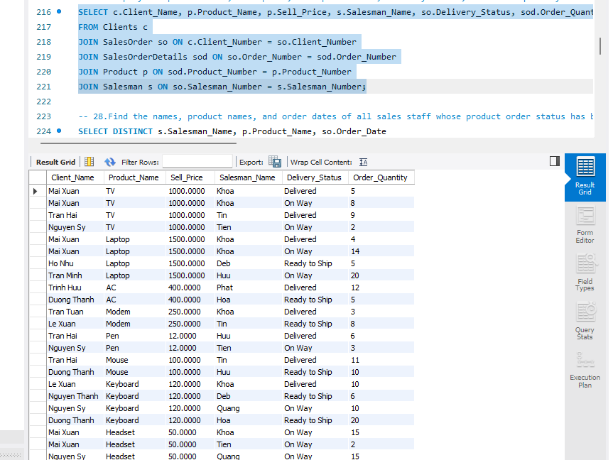
   6. Find the names, product names, and order dates of all sales staff whose product order status has been successful but the items have not yet been delivered to the client.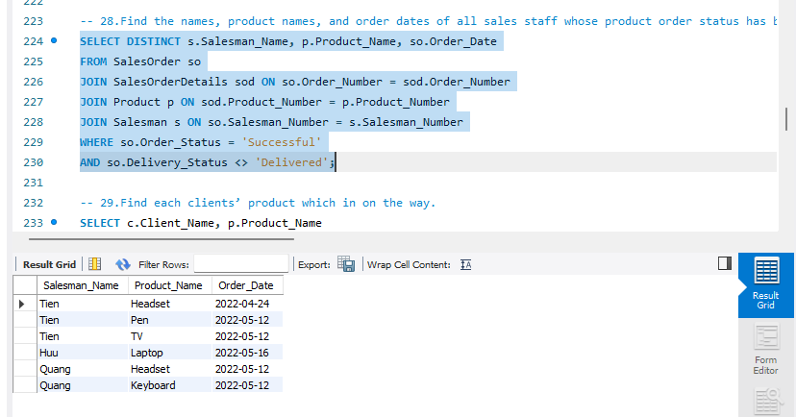
   7. Find each clients’ product which in on the way.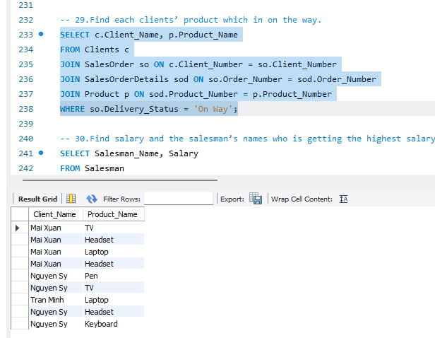
   8. Find salary and the salesman’s names who is getting the highest salary.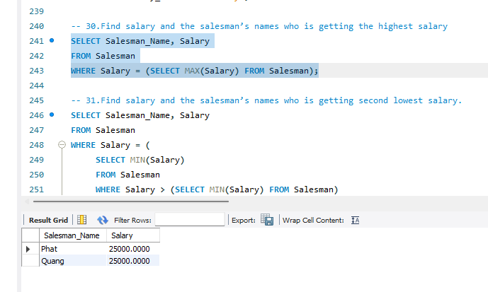
   9. Find salary and the salesman’s names who is getting second lowest salary.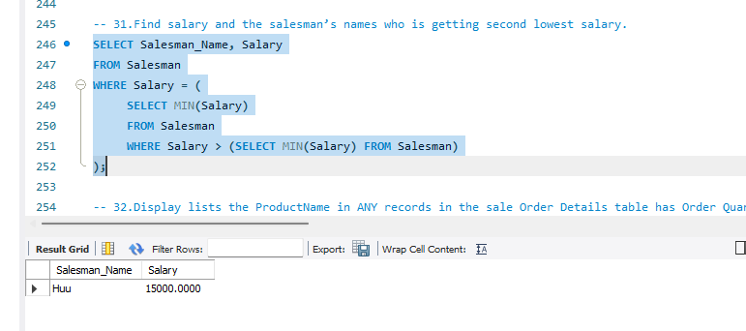
   10. Display lists the ProductName in ANY records in the sale Order Details table has Order Quantity more than 9.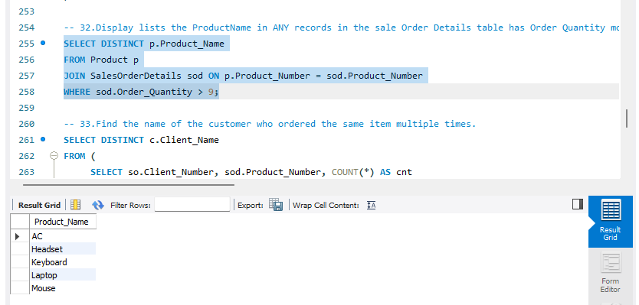
   11. Find the name of the customer who ordered the same item multiple times.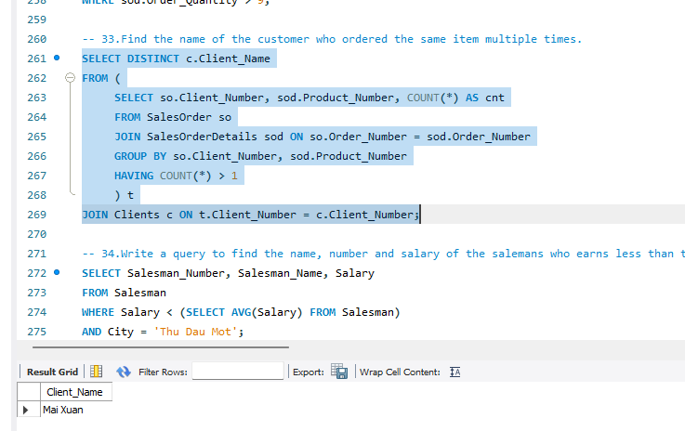
   12. Write a query to find the name, number and salary of the salemans who earns less than the average salary and works in any of Thu Dau Mot city.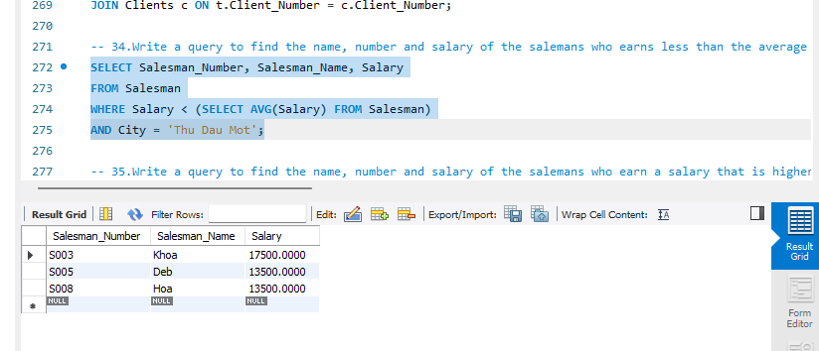
   13. Write a query to find the name, number and salary of the salemans who earn a salary that is higher than the salary of all the salesman have (Order_status = ‘Cancelled’). Sort the results of the salary of the lowest to highest.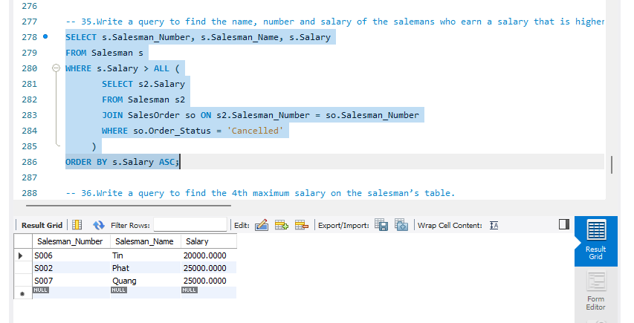
   14. Write a query to find the 4th maximum salary on the salesman’s table.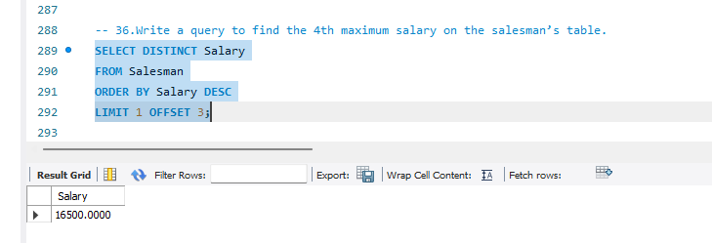
   15. Write a query to find the 3th minimum salary in the salesman’s table.